Name of Document Here  
Second Line of Title (if Needed)

Prepared by [Name]

May 12, 2021

Table of Contents

Summary 1

Styles 2

Heading 1 2

Heading 2 2

Heading 3 2

Bullet Lists 3

Bullet List 2: More Spacing 3

Tables 4

Alternate Text for Tables 4

Images 5

Alternate Text for Images 5

Charts 6

Alternate Text for Charts 6

References 7

The Table of Contents will automatically fill with your headers and page numbers. To update, click the table above, choose ‘Update Table’ from the tab, and ‘Update entire table’. Once you know how to update your table of contents, please delete this note from your new document.

The information contained in this document is copyright   
© Toronto and Region Conservation Authority

# Summary

Summary or introduction text.

# Styles

This report template uses styles for consistency. Styles can be found in the toolbar above. Make sure you are on the ‘Home’ tab, then click the ‘Styles’ button within the toolbar to access the drop-down gallery.

# Heading 1

The Heading 1 style is the largest heading format. It is 20pt bold, ALL CAPS, in a dark variation of TRCA blue. Paragraph spacing is 18pt above and 12pt below. The next style is set to ‘Body Text’, so when you press return/enter for a new line after the heading, the new line will automatically format as body text.

Heading 2

Heading 2 style is the next largest heading format. It is 15pt bold in a dark variation of TRCA blue. Paragraph spacing is 12pt above and 12pt below. The next style is set to ‘Body Text’, so when you press return/enter for a new line after the heading, the new line will automatically format as body text.

### Heading 3

Heading 3 style is the next largest heading format. It is 13pt bold in a dark variation of TRCA green. Paragraph spacing is 12pt above and 6pt below. The next style is set to ‘Body Text’, so when you press return/enter for a new line after the heading, the new line will automatically format as body text.

#### Heading 4

Heading 4 style is the smallest heading format. It is 11pt bold, in black. Paragraph spacing is 12pt above and 3pt below. The next style is set to ‘Body Text’, so when you press return/enter for a new line after the heading, the new line will automatically format as body text.

Body text - The body text style is Calibri 11pt in black. There is 12pt spacing below. There is no spacing above as this is typically set by the previous line’s style/formatting. The next style is set to ‘Body Text’.

# Bullet Lists

* Bullet List - The bullet text style is Calibri 11pt black.
* With this bullet style, there is no paragraph spacing between bullet points of the same style.
* This bullet style is ideal for lists with single words or short lines of text.
* Example
* Example

## Bullet List 2: More Spacing

To create a list that *does* include space between each bullet point, select the **‘Bullet List 2’** style from the style gallery drop-down menu, which includes paragraph spacing in its style format.

This is ideal for lists with longer sentences and points with multiple lines of text within each point.

Here is some example text. Here is some example text. Here is some example text. Here is some example text. Here is some example text. Here is some example text.

# Tables

The table shown below is in the default table style for this template (which is a variation of the built-in Word APA report style, with light blue in the header row). To create a table:

* Click the ‘Insert’ tab and then click ‘Table’.
* Select the number of rows and columns.

It is important to note that the table will automatically take on the style of the text in which it is inserted. This can cause undesirable font and spacing issues. Select your entire table and change the style to **‘Table Text’** from the style gallery drop-down menu. The ‘Table Text’ style is just slightly smaller at 10pt to allow for more text to fit in the table, and there is less paragraph spacing for optimal table margins.

To insert a caption with your table, select your whole table, right click, and select ‘Insert Caption’. You can then select labeling options (equation, figure, or table) and placement options (above or below).

|  |  |  |  |  |
| --- | --- | --- | --- | --- |
| Column 1 Head | Column 2 Head | Column 3 Head | Column 4 Head | Column 5 Head |
| Row Head | 123 | 123 | 123 | 123 |
| Row Head | 456 | 456 | 456 | 456 |
| Row Head | 789 | 789 | 789 | 789 |
| Row Head | 123 | 123 | 123 | 123 |
| Row Head | 456 | 456 | 456 | 456 |
| Row Head | 789 | 789 | 789 | 789 |
| Row Head | 123 | 123 | 123 | 123 |

**Table 2:** This is a table with a caption positioned below.

## Alternate Text for Tables

Adding alternate (Alt) text to tables will allow users with screen readers to be able to read what the table is showing. Alt text can be added by right clicking on the table and selecting ‘Table Properties’ and then the ‘Alt Text’ tab. Add a description that concisely communicates the information in the table.

# Images

When you insert an image, it will automatically take on the style (in terms of spacing, etc.) of the text within that line of the document. This could mean the spacing will create a larger gap than you’d like between the image and the caption text. To correct this, select the image and then select the **‘Image spacing’** style from the Style drop-down menu in the toolbar.

To insert a caption, right click your image and select ‘Insert Caption’. You can then select labeling options (equation, figure, or table) and placement options (above or below).

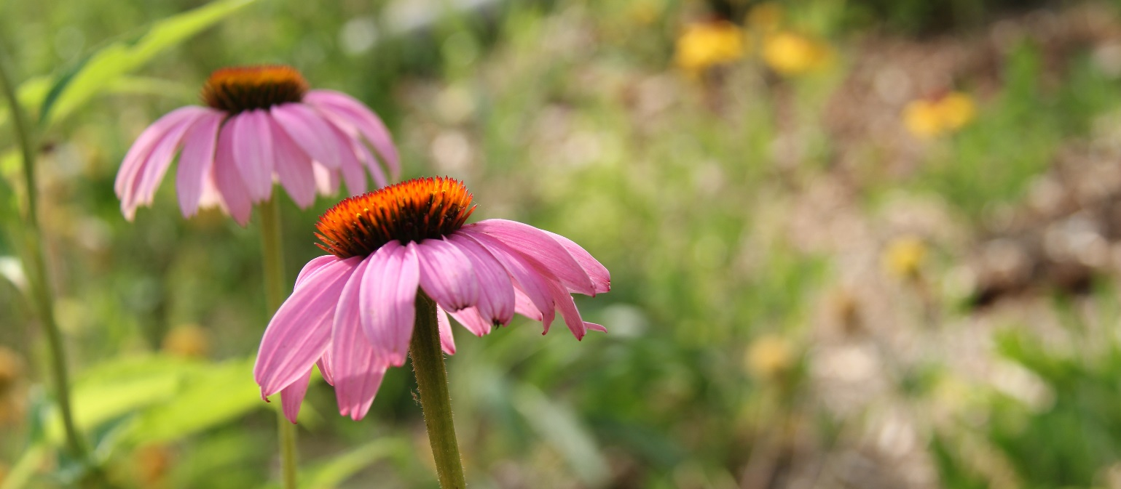

**Figure 1**: This is a photo of flowers with a caption.

## Alternate Text for Images

Adding alternate (Alt) text to images will allow users with screen readers to be able to read what the image is showing. Alt text can be added by simply right clicking on the image and selecting ‘Edit Alt Text’, which will open a task pane. Add a short description that communicates the most important information about the image.

# Charts

To create a chart:

* Click the ‘Insert’ tab and then click ‘Chart’.
* Select the style of chart you would like to use and input your information.
* Charts are automatically set to use TRCA colours in this template.

When you insert a chart, it will automatically take on the style (in terms of spacing, etc.) of the text within that line of the document. This could mean the spacing will create a larger gap than you’d like between the chart and the caption text. To correct this, select the chart and then select the **‘Image spacing’** style from the Style drop-down menu in the toolbar.

To insert a caption with your chart, right click the outer chart area (not on the chart data) and select ‘Insert Caption’. You can select labeling options (equation, figure, or table) and placement options (above or below).

Figure : This is a chart.

## Alternate Text for Charts

Adding alternate (Alt) text to charts will allow users with screen readers to be able to read what the chart is showing. Alt text can be added by right clicking on the chart area and selecting ‘Edit Alt Text’. Add a description that concisely communicates the information in the chart.

# References

Lorem ipsum dolor sit amet, consectetur adipiscing elit. Nunc sed semper magna. Maecenas vulputate id sem at varius. Etiam at laoreet turpis. Pellentesque feugiat felis in purus sollicitudin posuere.

Praesent tempus malesuada sapien, ac sodales justo ornare vel. Integer tristique, purus nec tempus malesuada, arcu ex dignissim lectus, quis pharetra erat sem non eros.

