Project Management Risk Evaluation Toolkit

Prepared by: Risk Management

October 2019

Summary:

This toolkit is designed to be used by project management staff to help guide a basic risk assessment process for a project of simple to medium complexity.

**Who should use this document?** Project Managers and Project Management Staff, involving key personnel, control groups and potentially external consultants.

**When should it be used?** As early in the Project Management process and then recurrently throughout the life of the project as new information is available.

**Where can the output of this document be stored?** In risk management toolkits and documents, the Centralized Planning and Reporting database and Project Charters.

**Why should I engage in risk management?** To maximize control of project uncertainty with the aim of improving the chance of project success.

Table of Contents

Introduction 1

1.1 Risk Management at TRCA 1

1.2 How to use this document? 1

1.3 Risk Assessment Process 2

1.3.1 Establishing Context 2

1.3.2 Risk Identification 3

1.3.3 Risk Analysis 4

1.3.4 Risk Evaluation 5

1.3.5 Risk Treatment 5

1.3.6 Putting it Altogether 6

Glossary 6

*The information contained in this document is copyright   
© Toronto and Region Conservation Authority*

# Introduction

This document is meant to guide a simple risk assessment process for a project or program of simple to medium complexity. A basic understanding of project and risk management concepts is critical to ensuring that the outputs of a risk assessment process following this guide effectively represents and manages and corresponding risk associated with the project being assessed. Staff are encouraged to review the [Risk Management Space](https://hub.trcastaff.ca/hub-spaces/risk-management/) on the HUB to become acquainted with general risk management concepts, as well as TRCA’s Risk Management Policy and Risk Tolerance and Appetite Statements which set the parameters of what risks are acceptable to the organization. Staff need to be aware that this document may not address all questions surrounding the risks that are identified, depending on the results, further study may be required.

## Risk Management at TRCA

TRCA has adopted the ISO 31000:2009 risk management framework which is shown in figure 1:

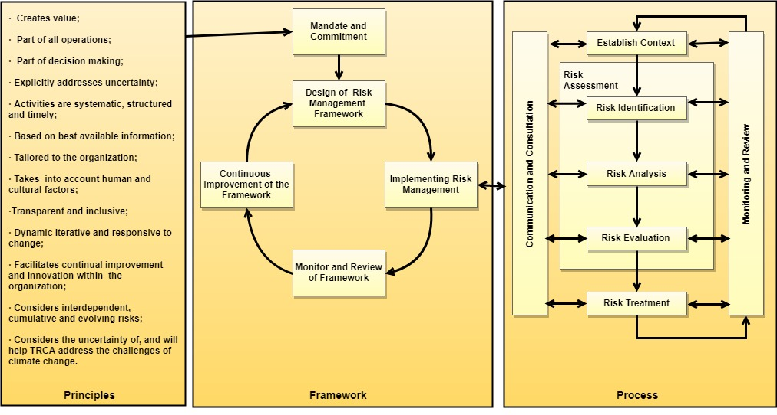

*Figure 1*. TRCA Risk Management Framework (adopted and modified from ISO 31000:2009)

ISO 31000:2009 provides an internationally recognized approach to tackling the issue of risk. In this case, risk is presented as the uncertainties that might have an effect on the project outcomes, not just the chance of something negative happening. The framework identifies the principles that should underpin or guide the risk management process, as well as the process for managing risk itself.

This document is aimed at guiding the Process of risk management and specifically that of Risk Assessment (which includes risk identification, risk analysis and risk evaluation) and Risk Treatment in the context of project management. Assessment involves the selection and prioritization of risks for treatment while treatment involves the review of methods to control risks as well as the implementation of those controls. Internal and external project context, communications plans as well as monitoring and review can and should be elements of the broader project plan and will be reflected in tools such as project charters and work plans.

## How to use this document?

This document will ask the individual or team conducting the risk assessment (Risk Assessor) several questions aimed at identifying and assessing risks facing the project. The Risk Assessor should consider risk as an uncertainty as opposed to just the chance of things going wrong or bad, the Risk Assessor must also consider the context within which their project exists while making an assessment.

Outputs can be either documented in the space provided for simpler projects, or outlined in risk tools such as risk registers, workplans, the Centralized Planning and Reporting Database or the Project Charter. Check the [Risk Management Space](https://hub.trcastaff.ca/hub-spaces/risk-management/) on the hub for templates you can use to track some of the outputs of this process as well as a list of possible risks that might face the project being assessed.

## Risk Assessment Process

### Establishing Context

When establishing the context, you are trying to assess what level of risk is acceptable to the project, but also what factors might be creating or affecting risks that are facing the project. The following questions are aimed at helping the Risk Assessor answer the question of how much risk is acceptable to the project. The question of what factors that might affect the project are better answered in documents like project charters or project specific documents.

1. After reviewing and considering your project charter and the Risk Policy can I/we accurately describe what level or risk is acceptable to this project?
2. After consulting my project sponsor, control group, and management team can I/we accurately describe how critical this project is to my business unit or the organization as a whole?

### Risk Identification

These questions are focused on identifying as many risks as possible that could affect the project. Sources of information that the Risk Assessor could use are past project summaries, claims histories, incident reports, consultant advice, technical staff opinion and many others. Consider listing these risks in a risk register, this will help organize risks and will set you up for the analysis and evaluation of the risks.

1. After reviewing all available information at this point in time, what are all the risks that I/we can think of?
2. Considering similar projects that we have undertaken in the past, are there any lessons learned or risks that we didn’t think of when answering Q3 that we should consider now?

### Risk Analysis

Here you are trying to answer the question of, on an individual basis, how likely the risks might be, what the effects might be and how much of an impact those effects might have. Here the Risk Assessor should review the Risk Tolerance and Appetite statements for the organization as well as the Project Charter to guide the assessment of terms such as likelihood and consequence for each risk. Despite this guidance, Risk Analysis may be difficult to do. The Risk Assessor should look to past records, past projects, technical advice and other sources to exercise best judgment when making an assessment of the potential associated with each risk. Certain risks, if they are difficult to assess and appear to have a high enough exposure, may necessitate further study or consultation to assess adequately. Again, the Risk Assessor will need to exercise good judgment in making such a determination.

1. For each risk I/we identified, what kind of effect will it have (reputation, bodily injury, property damage, reputation, project delay, financial, others)?
2. How likely are each of the risks I/we identified to present themselves?
3. How much of an effect or consequence might the risks have if they do present themselves?

### Risk Evaluation

In Risk Evaluation, we start to compare the risks against each other as well as the context within which we are operating. Here we begin the process of prioritizing the risks for action based on the effect they might have on the project as whole. Here we need to review the risks against the answers we develop in questions 1 and 2 to help determine which risks will be set for management first. This decision needs to involve decision makers commensurate with the level of risk being assessed to the project.

1. After analyzing each risk in isolation, and after reviewing question 1 and 2, my project charter and the Risk Policy, which risks are the most important ones?
2. Of the risks we identified, do any appear at first glance, too big for us to handle?

### Risk Treatment

In risk treatment we start to decide what to do about each risk starting with the most critical risks first and moving down the list. Typical methods of managing risks include:

**Avoiding:** here you would avoid the risk all together, this may involve cancelling a component or possibly the entirety of the project. The Risk Assessor should take caution that avoidance does not remove all risk and may even present new risks or challenges on its own. Example: The team is concerned that a special interest group might be upset and will lodge a negative public relations campaign because of a public information centre (PIC); as a result, the team decides to avoid the risk by cancelling the PIC altogether. Ultimately the special interest group gets wind of the cancellation and as a result they lodge a damaging campaign, and now regulators are concerned about the adequacy of the consultation program on the project.

**Reduction:** trying to reduce the impact that a risk might have.

**Prevention:** trying to reduce the likelihood that a risk might manifesting itself.

**Transfer:** Shifting responsibility for the risk to someone else.

**Retention:** Accept the risk and planning accordingly.

1. Starting with the most critical risks, is there anything we can do to reduce the negative effect of each risk or maximize our certainty around the risk?

### Putting it Altogether

At the end of this exercise, each risk should be re-evaluated to review the ultimate impact each one might have, even after considering risk treatment options. If the risks remain un-manageable or unacceptable, consultation with the project sponsor, or control group is critical to ensure that the project is still a viable and acceptable option to the organization.

If risks are acceptable when considering treatment options, the outputs of this exercise should be reviewed with the Risk Assessor, the project team and sponsor and then integrated into the project workplan in the form of a risk management plan. Such a plan can be as simple as taking the actions identified in Q10 as action items and assigning both resources and task owner to ensure that they are not overlooked.

Periodically throughout the project lifespan, or when significant changes arise within the project context, the Project Manager should review the risk management plan against this process to ensure that the analysis remains current and valid

# Glossary

**Financial Risk -** Risk arising from financial operations, may include possibility of loss, no loss or positive returns. Financial risks are typically external to the organization and often can be managed through financial contracts.

**Hazard Risk -** Risk to accidental loss including the possibility of loss or no loss.

**Operational Risk -** Risk arising from people, processes, systems or external events, may include possibility of loss, no loss, or positive returns.

**Risk** – The effect of uncertainty on objectives or outcomes.

**Risk Appetite** - The level to which the organization seeks out new risks or opportunities.

**Risk Management** – The process of making and implementing decisions that enable an organization to optimize its level of risk.

**Risk Tolerance** - The total level of risk that is acceptable to the organization at any moment.

**Strategic Risk -** External and systemic risks outside the control of the organization, or the project or program being managed.



**www.trca.ca**